**SIT283 – VR Development Challenge**

**Development Report**

**James Bolitho – Student ID: 218269434**

Before exploring the planning and development of this challenge I would like to quickly discuss the level of completion as well as potential opportunity. I spent a large portion of time in this project focused on the development of the weekly challenges as I saw this as an imperative development skill to my future aspirations. Resultingly, this did leave me with minimal time to complete the VR Development Challenge (this goes without saying in the time that I did have available I still invested my full attention and learning). I mention this as several of the features are bugged or incomplete and regardless of this position I wish to incorporate feedback provided and continue to develop this VR Challenge, given that I focused so much time on the weekly challenges I believe I possess the skill and potential to acquire the knowledge to in the future provide an absolutely complete release for market version of this challenge. Evidently, the aforementioned bugs etc are discussed in this report as well as the future potential for this product on the basis that hopefully additional feedback can be provided on these elements.

**VR Hearing Difficulty Experience**

An idea that appealed to me was the Therapeutic Application of Virtual Reality and furthermore providing activities that promote physical and mental regeneration. The mention of a ‘Deaf player’ set me into motion as I began to devise a solution that tackled the assessment criteria of the challenge, had reasonable VR application and necessity as well as increasing my own passion to invest time and resources into the project now and in the future (as I wish to continue developing this challenge in my own time).

Hearing difficulties are present amongst approximately 5% of the population with some of this population experiencing a complete loss of hearing. This can be a result of hearing loss through accidents or the weakening of hearing skills over time. For the creation of a Therapeutic Virtual Reality Experience I planned to integrate a series of Virtual Reality development patterns accompanied by my knowledge of Virtual Reality to produce the following idea:

The experience focusses upon interaction with a virtual friendly looking dog that the user can perform several different activities with. The chosen form of the dog represents that of a beagle a small active companion for the user immersed in the virtual experience. Becoming deaf can be a frightening experience so this application focusses on the transition through this difficult period were the effected person may be feeling alone or scared in their inability to understand through action and emotion (as humans we rely heavily on our hearing to help us through every-day tasks). The interactions that occur with the dog in the virtual reality environment can provide many different visual cues and sensations that can be interpreted without any use of auditory cues.

The initial idea was as follows, although as discussed throughout the duration of this document this idea changed over time for a multitude of reasons. The initial idea is:

-If a dog wags its tail (It may be happy and want to play)

-If the dog isn’t happy it might lie down on the ground and not move at all as it isn’t active.

-If the dog is jumping up and down in front of the user’s line of vision it might want to fetch a ball object that could be implemented within the game.

The experience itself would take place in a simplistic and well-lit environment like a local park with luscious green grass, plenty of trees, and no buildings in site. The multitude of soft colours such as the red and white rug that is the experience start are, the bright blue dog’s ball and the light greens of the ground and orange or blue of the sky are all visual cues to distract the user from their impaired sense of hearing. Also, the addition of autonomous movement can reduce the amount of focus required by a user’s auditory senses through flooding their visual senses. Ultimately acting as a distraction from one sense and steering focus towards another.

The key requirements of the project and how I aimed to target these requirements is included in the list of items below:

-Therapeutic application requirement: (Design of the interaction techniques must be appropriate to the particular therapeutic context, and the capabilities of the individuals involved). Interaction with the system for the course of the subject was initially provided through keyboard interaction as a result of the limitations placed on the project itself. Accordingly, a patient with hearing difficulty can still know or learn the format of a keyboard although at a later date integration would optimally occur with the HTC Vive headset and controller.

-Therapeutic application requirement: (Interactive elements of the experience must provide a suitably dynamic environment to achieve declared therapy goals. Any simulations or activities must be provided with controllable parameters that can be varied by the therapist in order to reduce the intensity of therapy or to customize needs according to the patient). Resultingly, two different modes were added to the experience allowing the therapist to alter the experience for the patient. This included the introduction of a timer that would differentiate between an introductory mode and a timed challenge mode. The introductory mode would allow the user to freely experience the simulation and become familiar with the experience itself whereas the timed challenge would require the patient to read the signals displayed to them by the dog in a quick time frame in order to achieve a successful result for the application (this mode would be applied to increase the rate at which the patient has to interpret visual cues).

-Therapeutic application requirement: (The visual appearance of the virtual environment must be appropriate to the therapy context, for example, varying degrees of realism may be appropriate to a phobia therapy, a distraction environment may need to be particularly stimulating to all the senses, and therapies for disabled users will need greater support for other unaffected modalities). The visual appearance is lightweight and filled with an abundance of different colours and motions to distract the user from their lack of auditory sense. The increase in visual cues once again implemented to distract from auditory cues.

-Therapeutic application requirement: (The virtual environment will need to be supported by the available hardware for input and output that is appropriate to the nature of the therapy. This choice should be carefully considered, including providing alternative mechanisms for achieving every task). Hardware for input and output is initially limited to keyboard key-strokes although through integrating Unity’s documentation on VR input and making use of the appropriate (Steam VR plugin) and (HTC Vive controller plugin) the virtual reality application would become much more suitable.

The required functionality for the project and how each task is solves is also briefly covered below as well as a more in-depth explanation within the Required functionality subheading.

-Scripts providing movement control (Player can move in the direction that they are facing, the virtual dog object has autonomous movement integrated depending on its current state and the ball object for the dog has kinematic movement integrated to curve based on rotation of the player to appear to go further if the player throws the ball higher at a specific angle). This encounters for basic and more complicated movement.

-Script providing direction (Player can rotate freely around the y axis to change the direction they are facing and accordingly move in that direction (player has limited y-movement so can’t move up or below ground level) Dog rotation to track the ball depending on position, ball direction changed depending on collision with the trees in the scene to bounce back in the opposite direction. This encounters for both basic and more complicated rotation.

-Sequence undertaken, state and transition management (Two state machines were implemented in the game, one dependent of the timer tool set up to track the remaining time in the simulation and one too control the behaviour of the dog dependent on interaction by the user) demonstrating a simple and sophisticated state machine and application of the state machine pattern.

-User interaction tool (Considering user interaction with the dog and the dog’s ball a hand tool was implemented, this tool allowed the user to pat the dog or throw the dogs ball which accordingly impacted the state machine of the dog) Therefore, the tool used is both appropriate and provides a high standard of functionality.

-Visual cues were necessary as auditory cues had no use in the simulation. (Accordingly, a number of external assets were used that increased the visual cues in the scene whilst remaining under the hardware specifications for poly count etc. This also includes dynamic movement and change of the player, dog, ball and hand tool as well as the hope to include animation in the future).

-User interface that can be interacted with and manipulatable to have a clear impact on the virtual world (the introduction of the timer value, which could be set to on or off dependent on a slider value accessible by the main menu impacted the mode of the game, additionally this changed whether the timer was present in the game as well as impacting the state of the rendered sky effectively increasing the visual cues, start interface, state machine pattern and autonomous movement).

-Autonomous simulation, additional interaction with this autonomous simulation led to a high-quality solution (the autonomous simulation is present in two features. The smallest being the automatic state change of the rendered sky dependent on the timer value in the main menu, and the most important being the random positioning of the dog depending on current states, which included three sets of autonomous movements each impacted by the level of interaction with the user of the experience leading to a high quality solution).

-The application includes a start screen with title, author details, purpose of experience, controls and the option to exit out of the experience. (I added a high level solution that included both the addition of a start screen and a pause screen within the experience, the start screen had a title and the following functionality based on buttons, options, details and controls sub-menu and the option to quit, the options menu had the ability to adjust the slider value and accordingly the timer value in the experience, the details menu explained the product and author details, and the controls menu explained the experience controls, quit functionality obviously quit the experience, the pause menu providing even further smooth flow in the experience, allowing the player to resume the experience, resuming the current time displayed on the timer if in use, reset the experience resetting both the experience and timer, the menu option allowing the user to return to the menu of the experience and another quit option to quit the experience from within the experience) Detailing a very high level quality of solution.

Accordingly, this document details a high-level solution for the required project, although the basis of implementation on a VR platform may still be questioned. Therefore, the reasoning for application as a virtual reality experience is discussed below.

-Not everyone automatically has access to a dog, the dog is an imperative part of this project in the context of learning how to read visual cues.

-People effected may not live anywhere near a park, they may live in another area where visual cues aren’t as bright and exciting adding to the difficulty the user experiences.

-The obedience and presence of a virtual dog, some people might have a dog but that doesn’t mean the dog will always want to interact or have as easily recognizable visual cues. Within the context of a virtual reality environment we can force the actions of the dog and therefore force visual cues to occur. We can force the nature of the dog to always be ready to interact much different to real life where the dog will only want to interact sometimes if at all. The forced natures of the dog allow the therapeutic application to occur and be beneficial to the user.

-The overall purpose of the therapeutic application is to provide a distraction to users. A therapist’s room may not necessarily be calming and therefore those who are experiencing the hearing difficulty may feel trapped or confined. People might anger quickly if a deaf person interacts with them in the real world but interacting with a dog in the virtual world will have no negative implications for those effected.

These reasons consolidate why the application is necessary to be experienced in a virtual environment.

**Required functionality:**

**1a. Scripts providing movement control:** -Scripts providing movement control (Player can move in the direction that they are facing, the virtual dog object has autonomous movement integrated depending on its current state and the ball object for the dog has kinematic movement integrated to curve based on rotation of the player to appear to go further if the player throws the ball higher at a specific angle). This encounters for basic and more complicated movement.

**a. Satisfaction of particular requirement** The requirement of movement required involving a change of position of one or more objects, simple solution was along an axis whereas more sophisticated solution was on a curve or dynamically responding to other factors (I have incorporated all of this requirement into my solution)

- The player user is allowed to move in the direction they are facing using the w or s keys on the keyboard. In doing so I have encountered for future development where a VR inputs system for the HTC Vive could be used. Accordingly, this would allow the direction to move in being faced by the current position of the VR head-set attached to the user. The player moves in such a way by translating their current position relevant to the camera attached to the player game object. The camera is attached in such a way that the user appears to be the camera. Accordingly, with the addition of the SteamVR and HTCVive controller plugins, the main camera currently attached to the player can be replaced with the VR camera, tying directly into the VR head set if calibrated correctly into the system. Hence using a hand as the tool for interacting with objects, seems as if to be the player hand but corresponds to HTC Vive controller. Using movement in such a way allows the player to update the way they are facing and then accordingly move in that direction. This type of movement was covered in early lab sessions in Weeks 1-3.

The dog itself has a form of movement, in the form of autonomous movement, this is further discussed in its own subheading so will only briefly be covered here. It allows the dog to transform its position between a series of points in the range of the ground floor for the experience accordingly to provide the dog with seemingly random movement unless user interaction occurs. This type of movement was covered in week3 labs.

The ball object within the virtual environment has kinematic movement attached as a more difficult form of movement. The ball relies on changing the velocity of an object relevant to time and acceleration as accordingly applying to motion laws of movement. The ball originally has no acceleration or velocity applied and applies these relevant to the way the character is facing. Velocity is set to 30 multiplied by the angle of rotation of the player around the x-axis in collaboration with a negative acceleration in the positive y direction of the world space of the game to give the ball an acceleration in a certain direction. Therefore, the ball corresponds to dynamic movement along a curve. If the ball was to hit a tree object it would collide with the trees collider and resultingly its velocity would be reversed and effectively the ball will move in the opposite direction as if bouncing off a tree. This type of movement expands on the ballistics launcher movement covered in week8 of the development challenges.

**b. Conducted research into solving the challenge**

Many possible options of movement where available for this solution. As evidential in the Unity documentation under movement the character could be simply rotated around an axis transforming the position of the player current to its movement along an axis, right, up and forward each corresponding to a different axis on a cartesian plane. The player needed to be able to move not just along a series of axis though especially not in the world space, therefore transform.Translate was used to update a players position along a certain axis relevant to its self. Making movement more dynamic and evidently possible in all available direction as opposed to 3 directions.

The movement of the dog always needed to be randomized in some form to create its autonomous movement. This can be further discussed in its own sub-section further within the document.

The movement of the Ball required some form of gravity to be applied, and I did initially consider simply using gravity on the ball as was explained to me in previous laboratory tutorials, however this would require the constant turning on and off of gravity, also if the player held the ball when gravity was one then the player may begin to move downwards to. Therefore, I removed gravity and made the ball have kinematic movement. Accordingly, now I could apply my own gravity as a negative acceleration and therefore reverse gravity, multiplying this by the velocity at which the ball was thrown to add both the component of normal gravity and additionally the velocity of the ball attaching the velocity value to be dependent of the value of the players rotation around the x axis. Accordingly, providing a curved effect to the balls movement. Then I could simply change two variables a few times velocity and acceleration for every instance the ball had action applied. Especially when colliding with a tree, I could simply register the collision and then apply a negative force in terms of velocity to the ball and it would bounce off in the other direction, keeping the acceleration the same so it would still have downward movement.

Resultingly, I sourced my knowledge of movement from the unity documentation and the previous knowledge I had acquired in the practical sessions held.

**c. Finding and reporting programming patterns or adapting and applying abstract concepts to produce professional quality results.**

There were minimal abstract concepts applied to the movement as each movement was based on an already existing pattern. The basic movement pattern applied to the player who moved in reference to a coordinate system. The autonomous movement of the dog was a self-made algorithm that focused on movement between two points borrowing the concept of MoveTowards from the unity documentation on movement between two points. The ball movement applied the kinematics pattern to create more dynamic movement and achieve a higher quality solution.

**d. Design solution**

Player movement:

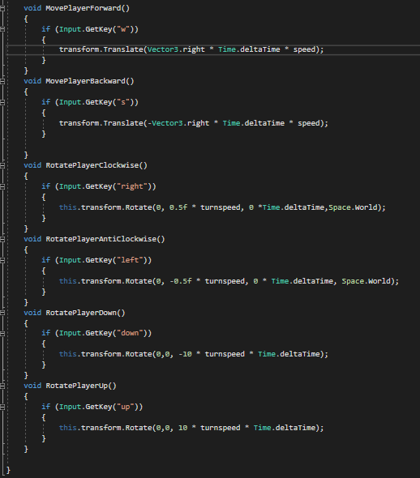

-Two movement functions corresponding to w and s keys in the forward or backward direction to be executed in the update function on every frame.

-Accordingly the movement updates relevant to the players current position relevant to themselves at a certain speed using time.deltaTime to move relevant to time rather then frames.

-The rotation is also shown here to demonstrate the movement around the y-axis allowing the user to move in any direction given that the user is facing that direction

-Not seen here but the player had a limited transformation of y to prevent flying or falling.

-This shows my ability to clearly initiate basic movement relevant to the keyboard

Dog autonomous movement: Is discussed in a later sub-heading

Ball movement:

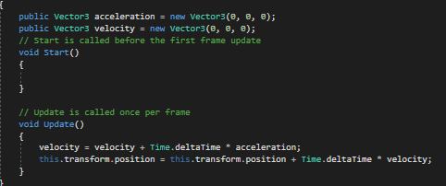

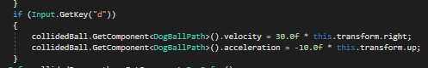

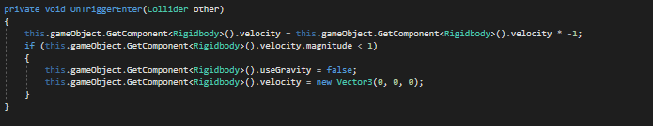

-Evidently the ball uses kinematic movement based on an assigned acceleration and velocity relevant to the current transforms of the player. Additionally, on collision events determine that I can create movement based on these same collision events. Evidently I have also acquired the knowledge to access information from other scripts such as the rigidbody of a specific object or the acceleration and velocity of the ball and change these values depending on collision. This demonstrates my ability to incorporate highly dynamic movement into the solution.

I learned how to refer to variables from other developers who explained the concept of inheritance ‘reference 1’ and demonstrated the use of this referencing ‘reference2’.

**e. Proof of functionality and testing**

It is important to notice the limitations observed through testing and features that could be implemented in the future.

-Set a collision event for the ball colliding with the fence that stops the ball from going outside the fence.

-Set a collision event for the player colliding with the fence that stops the player from going outside the fence.

-The ball depending on velocity and acceleration can sometimes have a value that is just below the specified value to not fall below the floor and accordingly can begin to sink below the floor

-The tree sometimes wouldn’t recognise collision and the ball would go through the tree.

-If the player through the ball in such a direction when they were facing down they could sometimes be thrown into the air due to the force being applied to them.

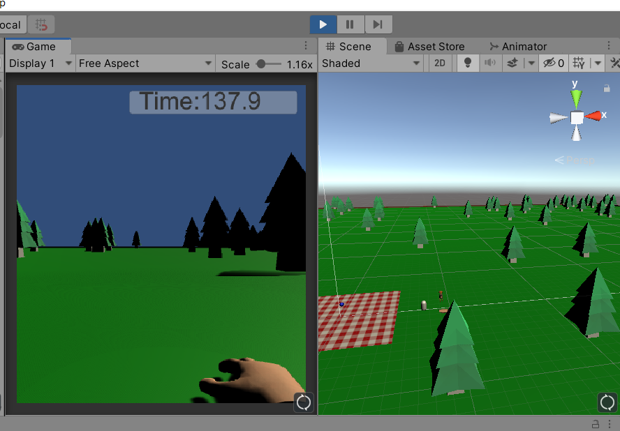

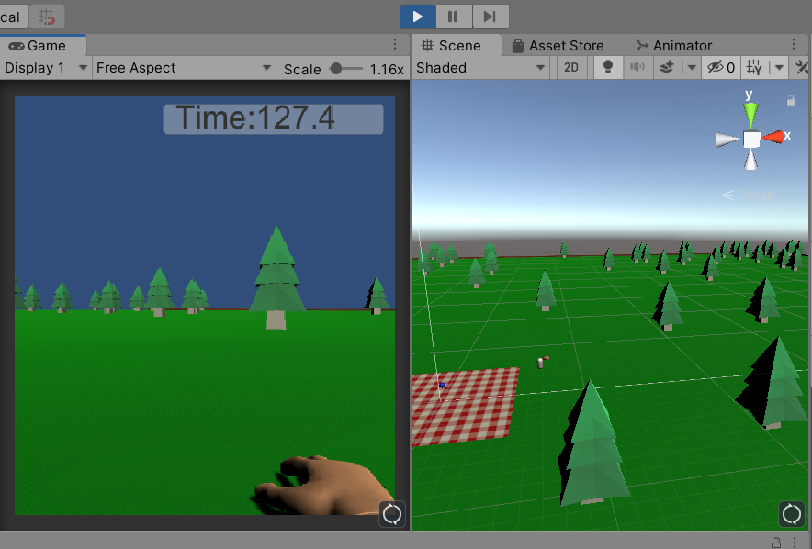

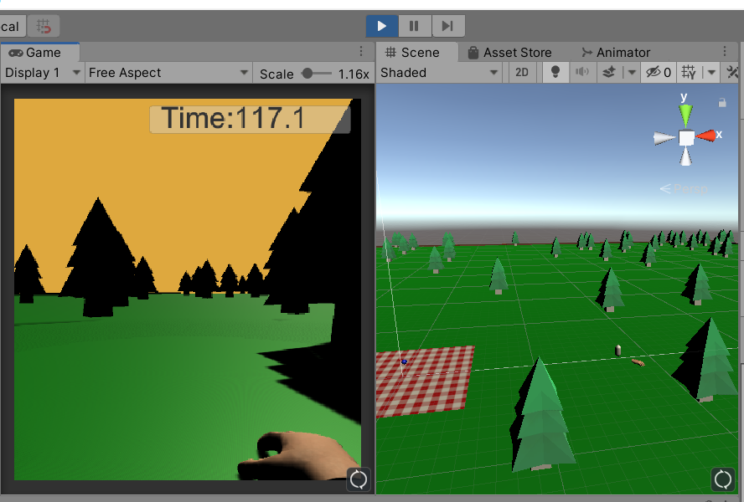

The above three screenshots demonstrate the user moving in three different directions, this movement is in the direction that the user is currently facing.

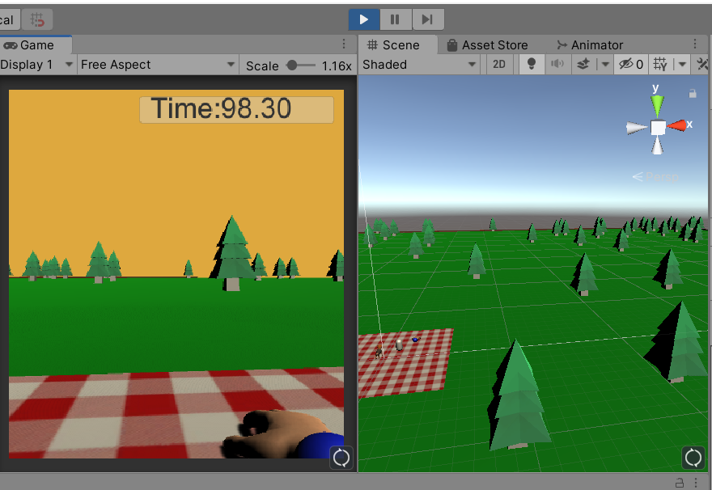

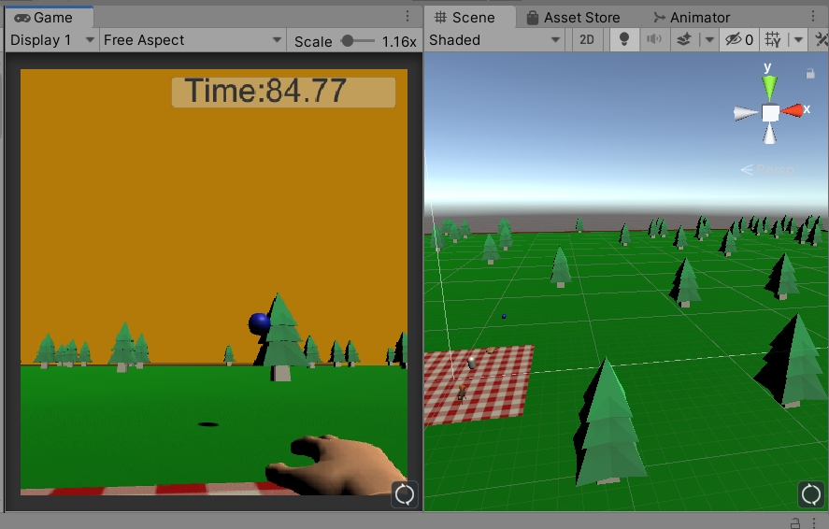

In the above two screenshots the user can be seen to have the ball and then be throwing the ball, when the user is holding the ball it is simply transformed to the position of the collided hand and no acceleration or velocity is applied but when the user throws the ball acceleration and velocity is applied creating the dynamic curved movement of the ball.

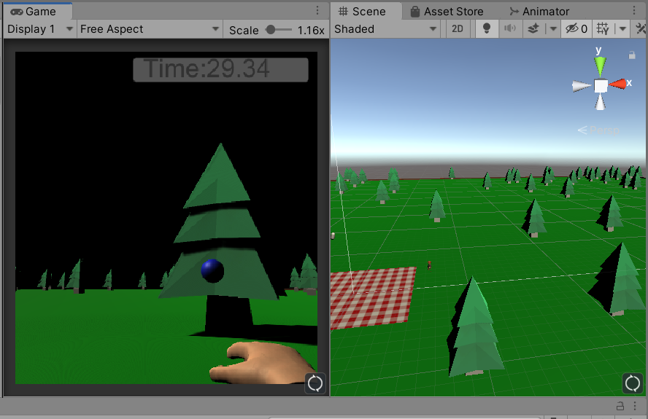

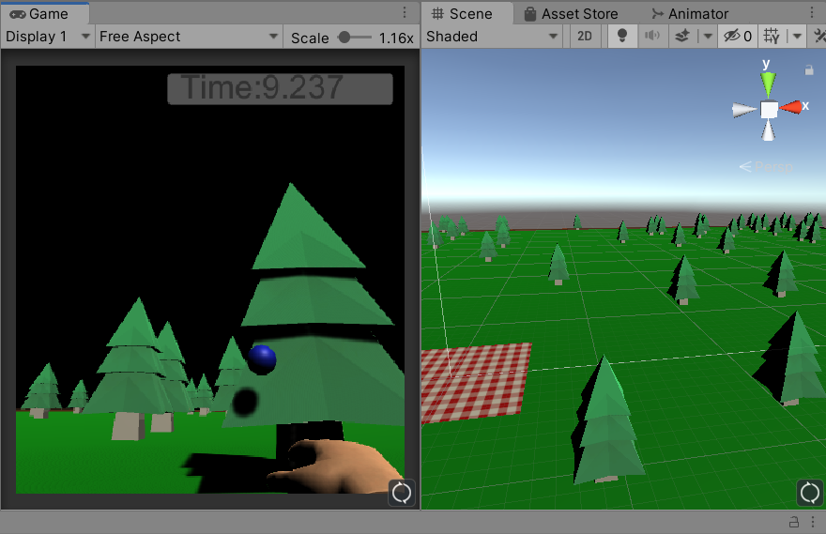

Finally, in the above last two screenshots the ball can be seen to collide with the tree object and then bounce off in a different direction based on the velocity and acceleration that had been applied to the ball.

Consequently, I believe that I have completely satisfied the requirements of this functionality and have provided a high quality solution.

**1b. Scripts providing direction:** -Script providing direction (Player can rotate freely around the y axis to change the direction they are facing and accordingly move in that direction (player has limited y-movement so can’t move up or below ground level) Dog rotation to track the ball depending on position, ball direction changed depending on collision with the trees in the scene to bounce back in the opposite direction. This encounters for both basic and more complicated rotation).

**a. Satisfaction of particular requirement**

Rotating a player around the axis is basic rotation imperative for changing the direction that the user can move in. As discussed the addition of a VR headset being calibrated would allow for the user to change rotation dependent on the rotation of the users head in the real-world. Player rotation around an axis was achieved by using the transform.rotate functionality discussed in the practical sessions in early weeks 1 and 2. This accounts for basic rotation and direction. An more sophisticated direction movement can be seen in the ball object as previously discussed through its reversal of direction by the kinematic properties applied although this has no rotation aspect. Additionally, in the future I wish to implement rotation of the dog to track the ball object, I couldn’t quite achieve this in the end and production of this feature stopped in the research stage.

**b. Conducted research into solving the challenge**

As discussed the only complete rotation of an object is that of the player character itself. I achieved exactly what I wanted with the player character through understanding the concepts of rotation and Euler angles as discussed in early practical classes. Using transform.rotate relevant to the world-axis for rotation around the y axis meant the player could constantly rotate in any of the 360 degree angles left and right and accordingly collaborate with movement to move in that direction. However, rotating relevant to the player for rotation around the z-axis had to be restricted, considering that movement corresponded directly to the rotation faced I simply limited where the player can move as a y-height value and therefore when the player looked up or down they could not move forward and therefore float or sink. I understood most of this content on my own from the practical learnings but needed to consort with the unity documentation about rotating relevant to the world space or object space.

**c. Finding and reporting programming patterns or adapting and applying abstract concepts to produce professional quality results.**

Once again the basic rotation patterns covered explored the rotation around two of the three axis on the cartesian plan. This allowed the player to not be able to rotate sideways as in the context of the VR solution the player would be standing up, rotation sideways isn’t within human nature and accordingly the user would fall over trying to keep the position of the head in the same position as the body. Therefore no rotation around the x-axis was applied to strengthen the realism of the VR experience.

**d. Design solution**

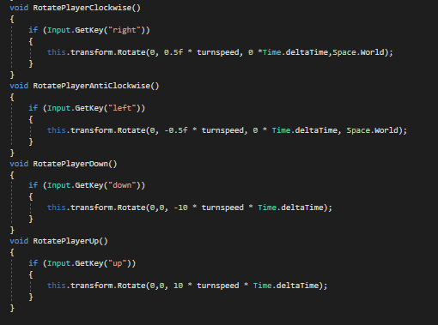

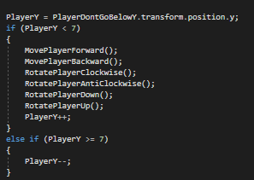

-From the above two photos the basic movement of using the rotation aspect of transforms can be observed once again relevant to time and the respective space that I wanted the rotation to occur in. Additionally, this corresponded to movement based on a key stroke. Also, it can be observed that I limited the y-value that the player could be, including the height of the player and the height of the player upon rotation. Evidently, a value of 7 fixed the solution considering the player could also not move through the ground as it was a rigidbody.

**e. Proof of functionality and testing**

Limitations to the rotation were evident in:

-The players hand could still disappear through the ground. This wouldn’t have any impact on the player as no collision could occur between the objects however it wouldn’t seem very realistic in a VR application that your hand could go through the ground and might cause a level of discomfort for the user if they see their hand disappear, note we are trying to avoid discomfort.

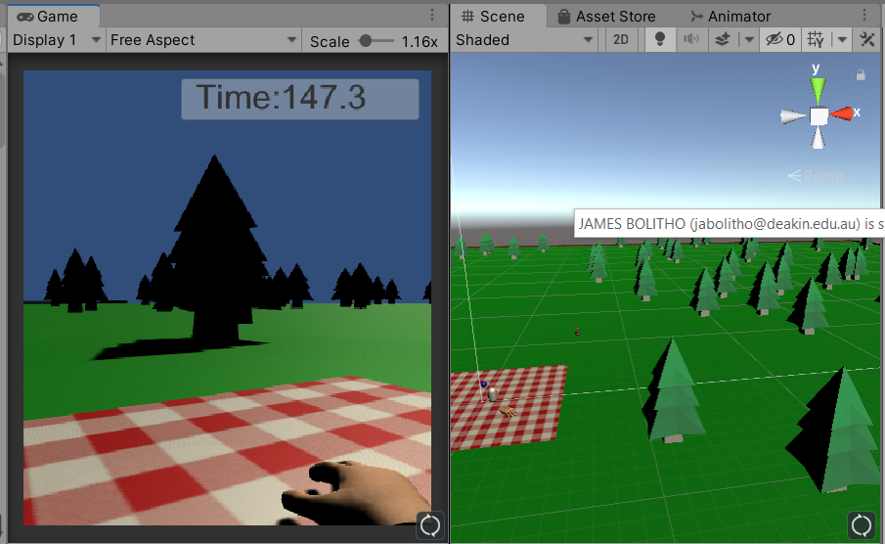

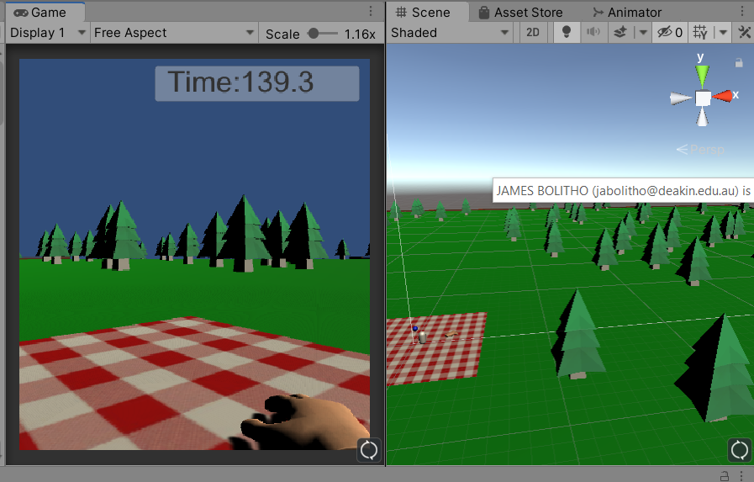

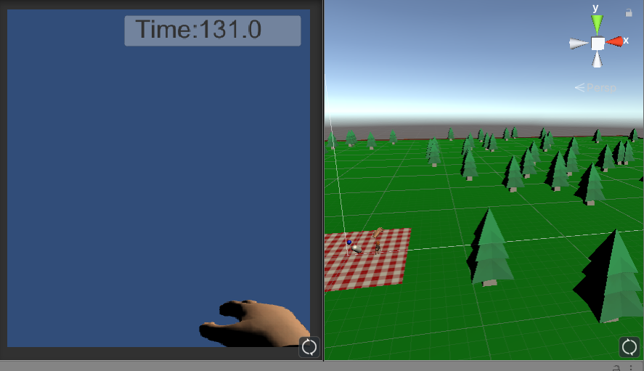

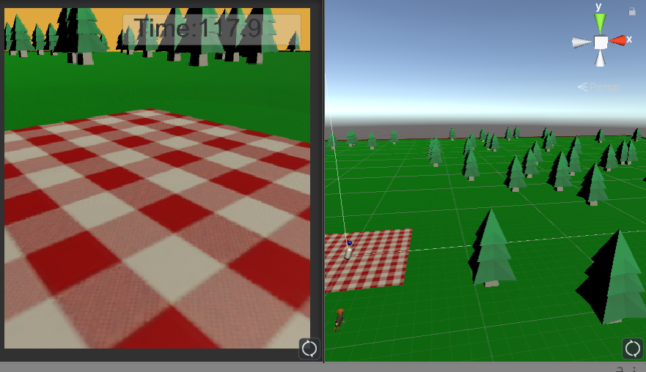

Evidently in the above four images it can be seen that rotation can occur appropriately around the z and y axis, the y-axis relevant to world axis and the z- relevant to player axis allowing a solution that would be appropriate for the context of virtual reality considering that the user would be able to look up, down, left and right with ease but looking sideways wouldn’t result in falling over.

For this outcome I believe I have covered the form of direction control allowing objects to be rotated and it is quite robust given the restrictions based on rotation, however I have added no sophisticated movement as of yet such as rotation of the dog to track its ball.

**2. Sequence undertaken and state transition:** -Sequence undertaken, state and transition management (Two state machines were implemented in the game, one dependent of the timer tool set up to track the remaining time in the simulation and one too control the behaviour of the dog dependent on interaction by the user) demonstrating a simple and sophisticated state machine and application of the state machine pattern.

**a. Satisfaction of particular requirement**

To achieve the state machine requirement I chose to implement two state machines into my design. One focused on the rendering of the sky relevant to the in-game timer and one relevant to the dog which included depth and sophistication by immediately being effected by the actions of the player. The sky state machine changes colour for different states and enters a different state based on the time currently displayed in the experience. This is a simple state machine that covers the transition of events. The next state machine is that of the dog’s movement. The dog can enter a number of states such as its starting position, the autonomous movement roaming state if the ball hasn’t been touched in the game or the dog hasn’t been touched in the game. The dog retuning to only roam within the boundary of the picninc rug if the ball has been touched or the dog has been touched. The dog roaming in the picnic rug boundary until such a stage as the ball was no longer being touched and the ball had been thrown at which state the dog would enter the move towards ball state where the dog would wait for several seconds also demonstrating the coroutine function before going to stand near the ball if the ball had been thrown and hit the ground. And then the dog transitioning to jumping and wanting to fetch the ball again if the player had petted the dog (note the player interaction also occurred with the player throwing the ball) or waiting for a period of time if the player had not patted the dog and just continue to roam around the map.

**b. Conducted research into solving the challenge**

For this element I used my knowledge of the state machine pattern as acquired from the Monster fun book of VR as recommended to be read by the unit site and my knowledge of the weekly practical sessions. However, for changing the colour of the sky rendered I needed to consult ‘reference3’. From here I simply coded the movements of the dog first before moving them to the state machine for transition and similarly I changed the value of the sky depending on the dynamic moving value of the in-game timer I had set up.

**c. Finding and reporting programming patterns or adapting and applying abstract concepts to produce professional quality results.**

The pattern used was that of the state machine pattern. An important pattern for transitioning between events. I applied the abstract concept of changing the value of the sky and hence the colour as I realised this could be used to add an additional visual cue to the experience.

**d. Design solution**

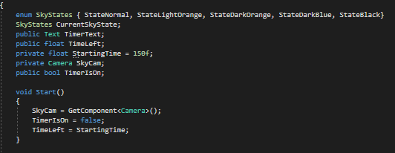

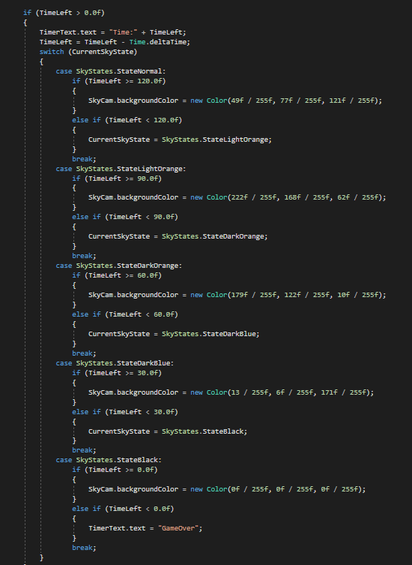

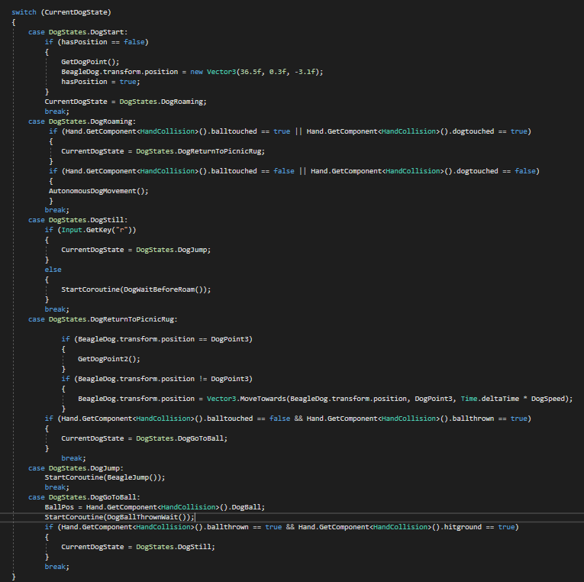

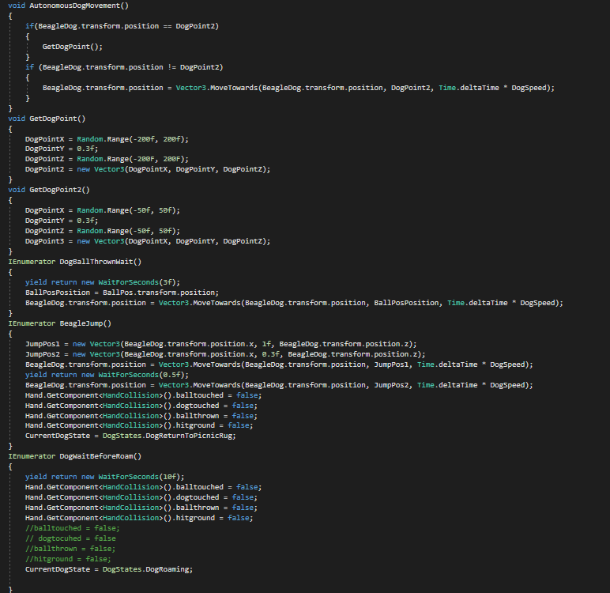

Evidently from the above four images the construction of the two state machines I implemented can be observed. The first image shows my knowledge of using enumerations to be used as a feature I can switch between using a switch case which is demonstrated in image 2 and 3 respectively. For the basic sky states it was easy to get the value of my timer and then change the rendered colour of the sky depending on this value based on 30 second intervals. Covering a basic transition of events however for a more complicated transition of events I also added states to the movement of my dog as discussed above. Evidently, through accessing other script components and utilising my own functions as well as coroutine functions I demonstrated how a switch case can easily transition between events even when user interaction occurs using several boolean statements to determine if specific user interactions had occurred. Then it was a matter of applying the appropriate function to have my dog perform accordingly to the state it was currently in. Proving an adequate knowledge of state machines and how they can be implemented in code to improve event transition.

**e. Proof of functionality and testing**

-Unfortunately, the timer value is always present and no event occurs when the game is considered to be over

-The boolean values need to be adjusted as the dog goes back to autonomous movement after several instances of the interaction if not executed properly

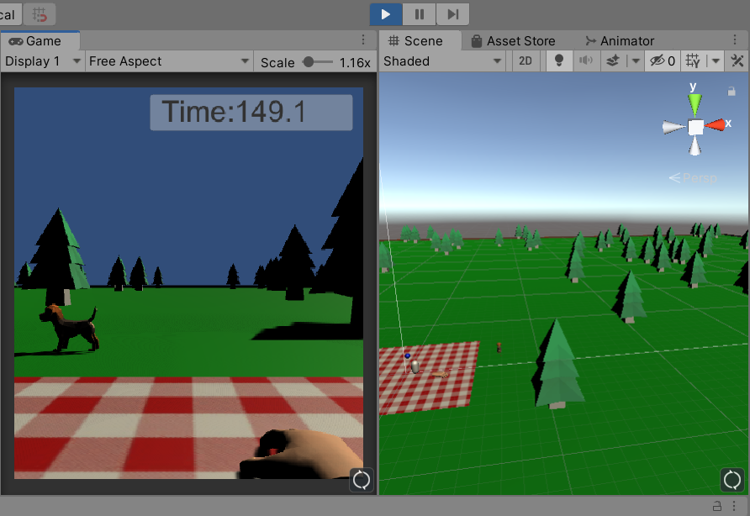

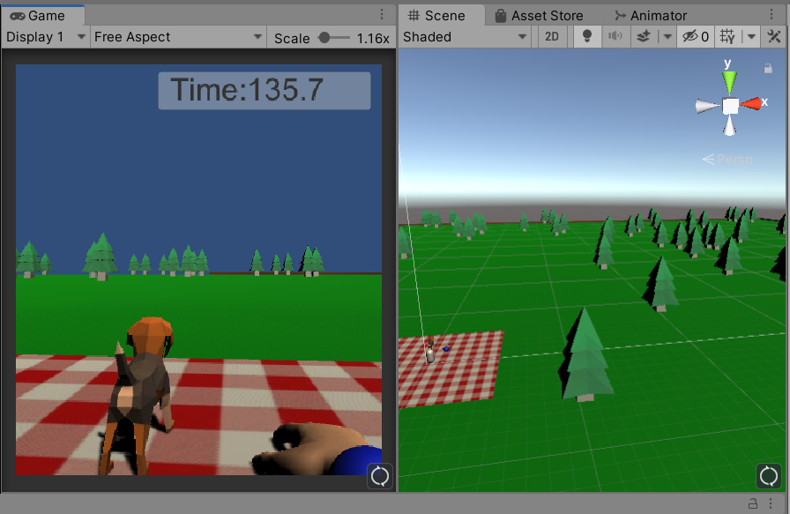

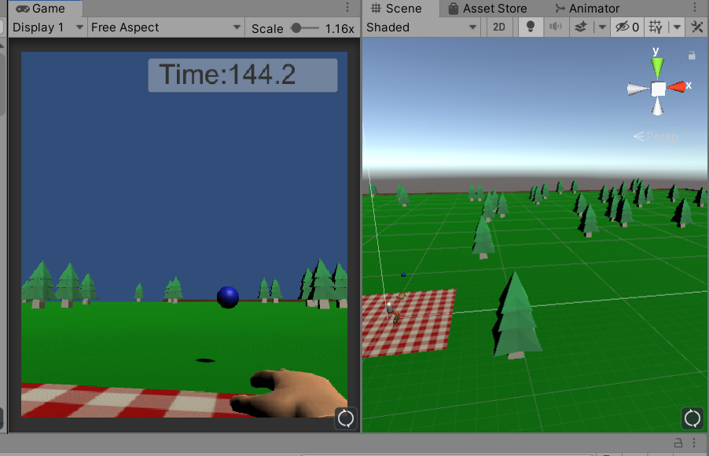

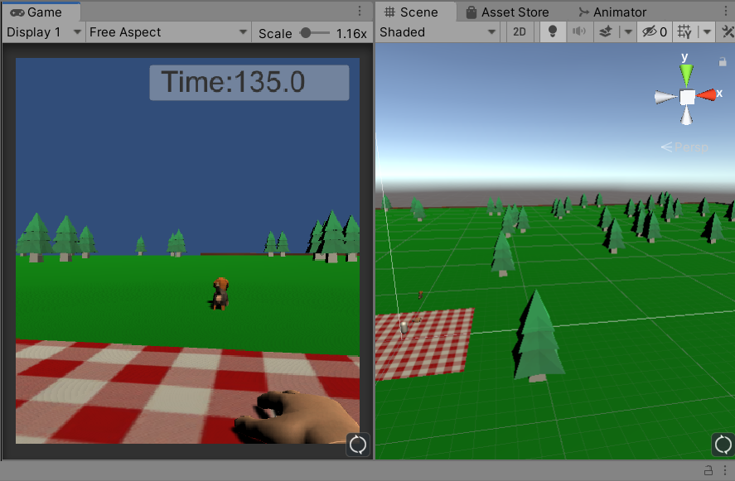

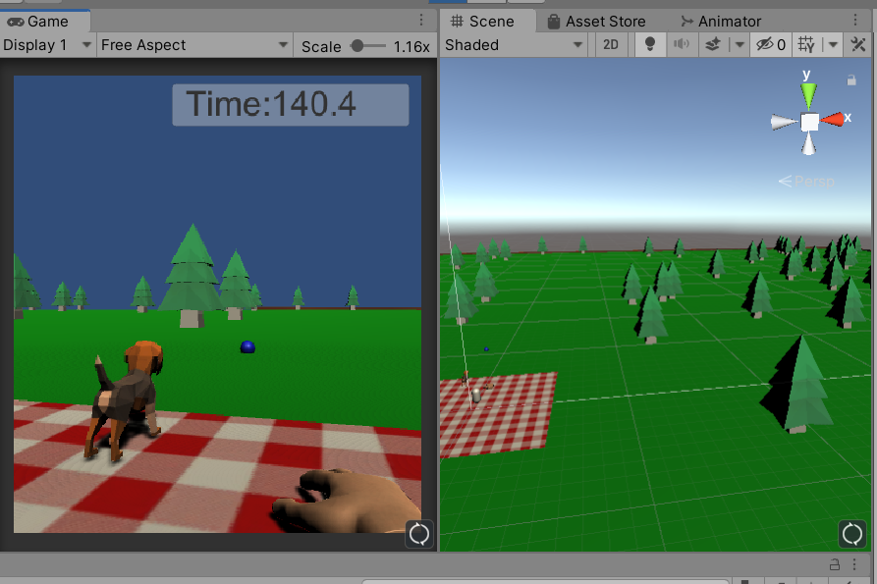

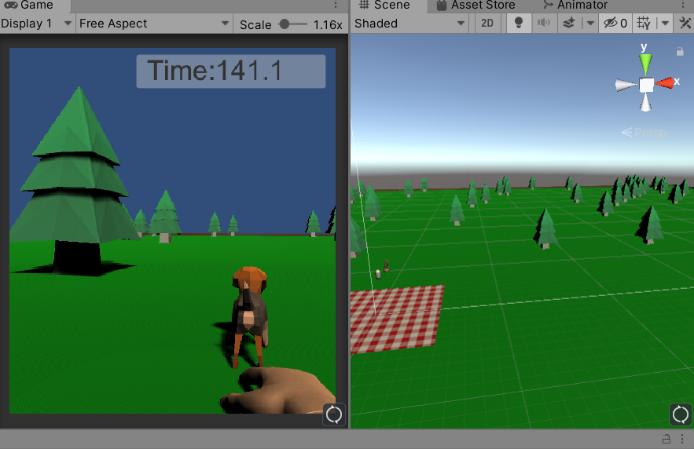

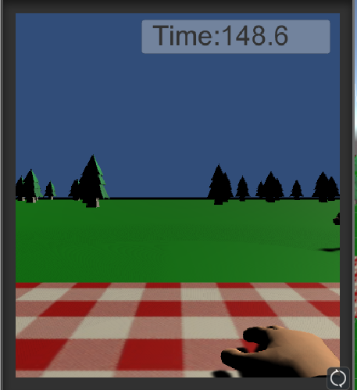

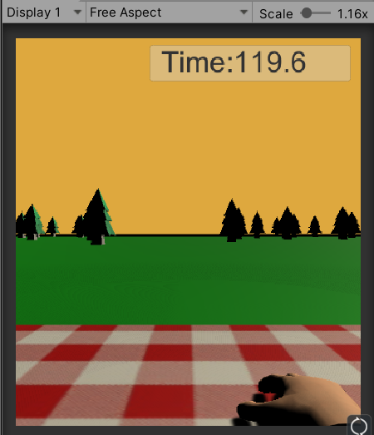

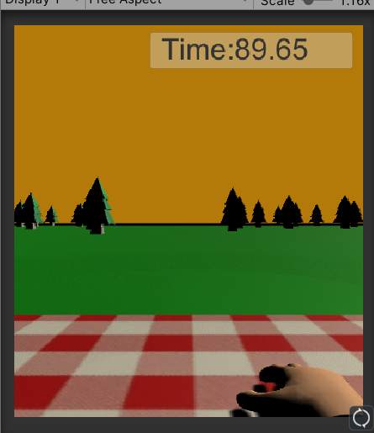

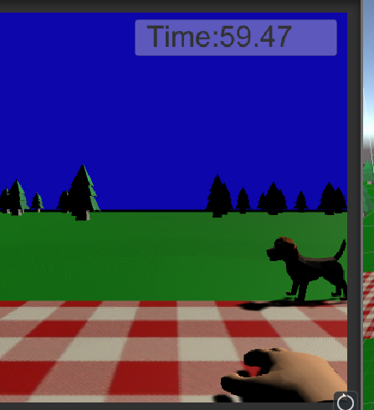

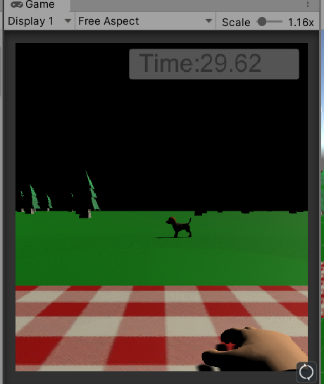

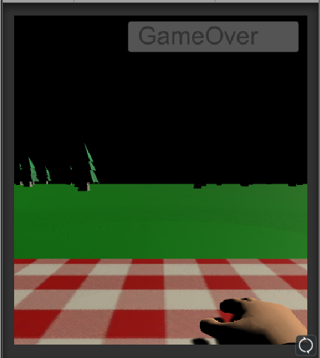

-State1: Dog doing autonomous movement (Roaming state)

-State2: Dog roaming in mat(Dog return to picnic rug state)

-State3: Dog waiting for ball after thrown ( dog waiting during dog picnic transition to dog toward ball)

-State4: Dog stand still on ball (Dog standing still state)

-State5: Dog move towards ball (Dog go to ball state)

-State6: Dog jump (Dog jump state) – hard to visualize as it is a quick jump

-State1: Normal sky

-State2: Light orange sky

-State3: Dark orange sky

-State4: Dark blue sky

-State5: Black sky

-State6: Black sky + gameover

I believe I have satisfied all the requirements of this required functionality point.

**3. User interaction tool** -User interaction tool (Considering user interaction with the dog and the dog’s ball a hand tool was implemented, this tool allowed the user to pat the dog or throw the dogs ball which accordingly impacted the state machine of the dog) Therefore, the tool used is both appropriate and provides a high standard of functionality.

**a. Satisfaction of particular requirement**

For the interaction of a tool I chose to implement a hand tool that could be used to pat the dog or throw the dogs ball. Implementing this through a hand was suitable considering the context of the solution and increases realism when applied to a virtual reality application. I have displayed how this tool can interact with different features of the environment based on collision events showing my knowledge of a tool to manipulate the environment and collision events themselves.

**b. Conducted research into solving the challenge**

The hand tool seemed an appropriate addition to the project considering that a user would look down and be able to see their hands. This is implemented by many popular virtual reality experience and tools such as a wand or other tools would not have been useful in the situation.

**c. Finding and reporting programming patterns or adapting and applying abstract concepts to produce professional quality results.**

The implementation of a tool is a pattern necessary for all virtual reality applications. The user needs some way to interact with the virtual environment. First I analysed what elements of the environment could be interacted with or needed to be interacted with accordingly this was the ball and the dog. Then I created collisions for these objects and applied action to occur based on the type of collision, and what the hand tool was colliding with. The item collided with would then undergo some sort of action to establish the changing of the environment.

**d. Design solution**

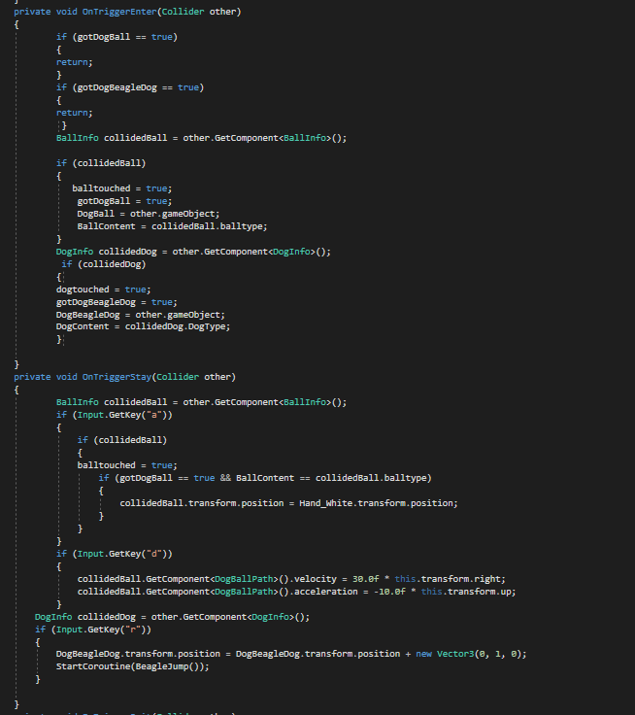

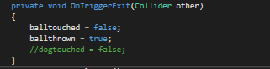

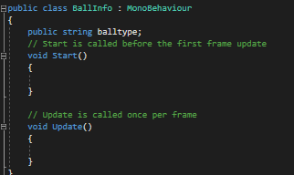

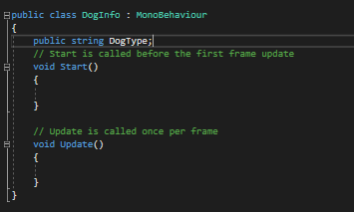

The above four images demonstrate how I achieved this functionality. The first and second image show the ontrigger events associated with the hand colliding with another object whilst images 3 and 4 demonstrate the attachment of small classes to the object being collided with to acknowledge the appropriate item being collided with. Accordingly, as evident from the collaboration of image one and two and the knowledge of the state machine the hand tool could interact with the ball and the dog. If the hand tool interacted with the ball several boolean values were created to determine the appropriate result of the collision with the same concept applied to the dog. Allowing the ball to be touched and thrown, and the dog to be touched and patted.

**e. Proof of functionality and testing**

-Ball object appears to be behind hand when touched

-Sometimes the ball object can go through the floor

-Drag and Angular Drag was implemented to stop the ball from being lost to easily when the player moved with the ball in their hand.

-The ball needs to be held using the ‘a’ key as soon as it is touched or the ball registers that the ball had been thrown (on trigger exit event occurs).

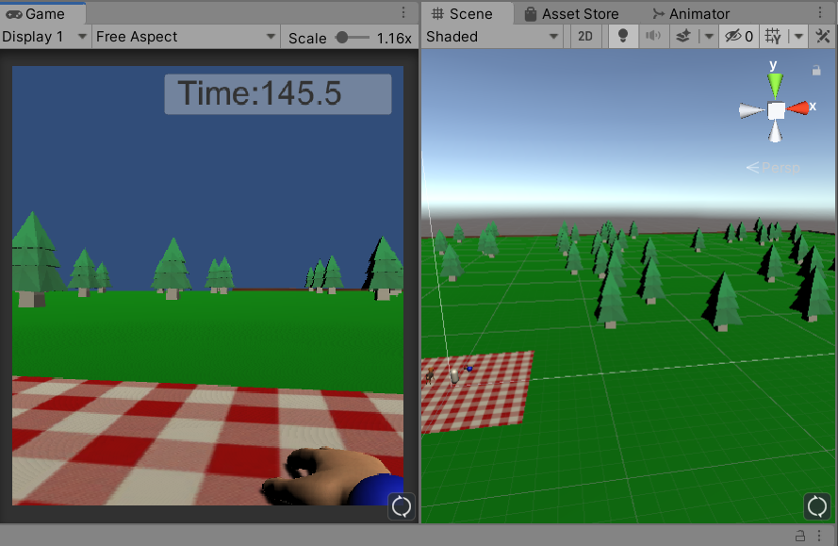

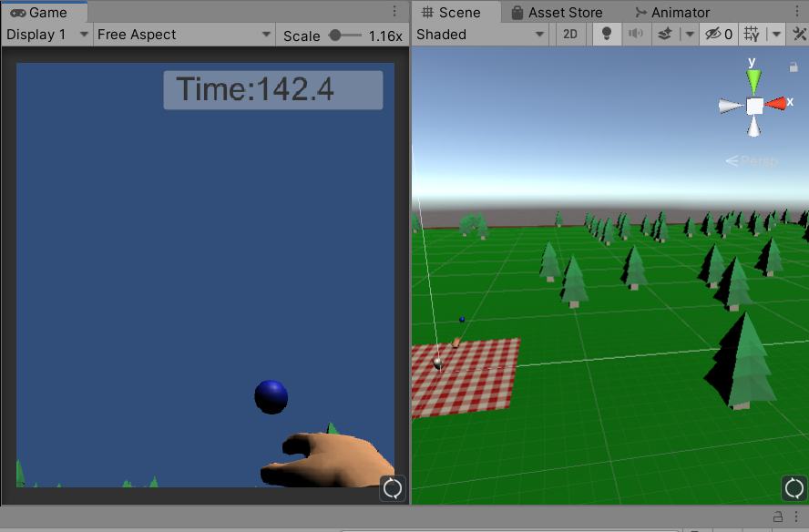

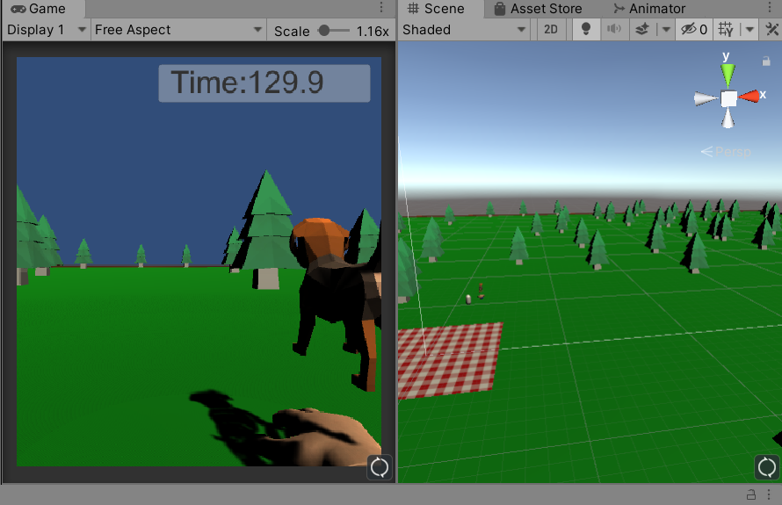

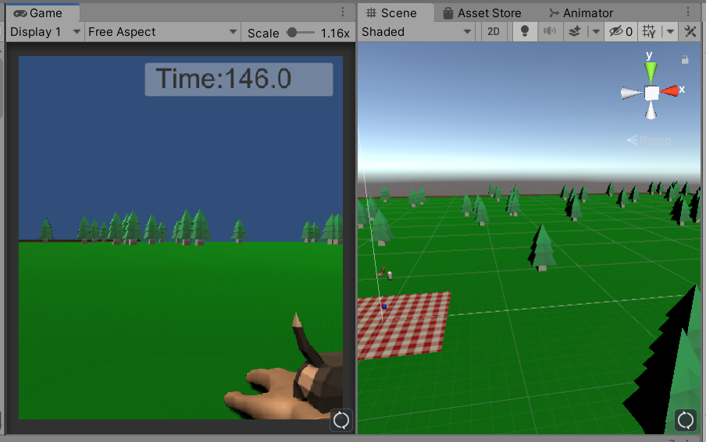

Image 1: The ball being touched (position of ball = position of hand)

Image 2: The ball being thrown (apply kinematic ball motion)

Image 3: The dog jumping (dog jumps to reset state if patted pressing r)

Image 4: The dog being touched (also required for a dog state change)

I believe I have satisfied all requirements of the solution.

**4. Visual cues in the simulation** -Visual cues were necessary as auditory cues had no use in the simulation. (Accordingly, a number of external assets were used that increased the visual cues in the scene whilst remaining under the hardware specifications for poly count etc. This also includes dynamic movement and change of the player, dog, ball and hand tool as well as the hope to include animation in the future).

**a. Satisfaction of particular requirement**

I established visual cues from creating a number of texture, materials and motion as well as downloading other assets from the unity store. In addition to this I wish to implement animations to the dog in the future that were provided with the purchase of the dog asset from the unity store. This will significantly increase how the visual cues are represented especially in terms of flooding the user with visual information to replace auditory cues.

**b. Conducted research into solving the challenge**

To solve this challenge, I needed to find assets that were appropriate to the VR experience I wished to develop. Accordingly, I desired to create an experience that required both suitable assets as well as assets that could be used in a VR environment with respect to modification and poly count, rendering and animation.

**c. Finding and reporting programming patterns or adapting and applying abstract concepts to produce professional quality results.**

First I needed a hand tool the would suit the environment. Accordingly, I purchased a hand tool that looked like a hand, had different states that could be implemented in the future such as pointing and clenched hand, these could correspond to different dog movements. More information about the hand tool can be found under ‘Reference4’. I didn’t sacrifice poly count for this item because we want the hand to look as realistic as possible for the solution.

Second I needed a dog that would be able to have a low poly count, therefore I found a dog asset under ‘Reference5’ that: had a low poly count, had several animations that could be implemented at a later date and therefore could heavily improve the credibility of the solution and also filled the desire for the dog to be a friendly looking dog.

Last I downloaded a low poly tree as I required to develop the scenery using a low poly model that could be instantiated to fill the scene and provide death. Resultingly I found one using ‘Reference6’.

From here I added the textures that came with all of the purchased assets to the respective assets whilst creating several textures of my own for the picnic rug object, the park fence object and the ball object. Additionally, creating two text mesh pro gradient colours for my text features to add some more form of visibility.

**d. Design solution**

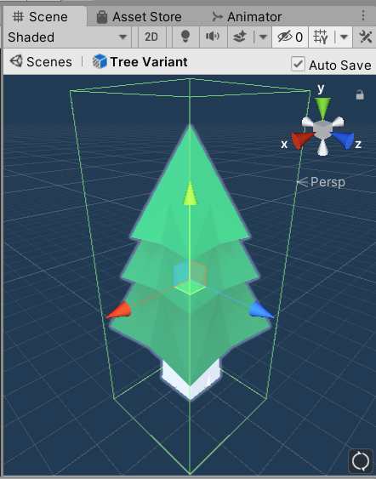

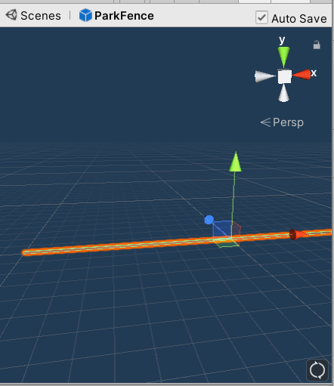

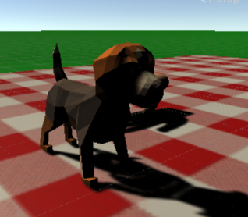

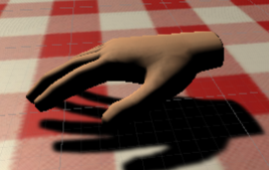

Evidently the above four models demonstrate all the prefabs required for the experience that have been downloaded as external assets with the exception of the fence that was created using a cube and a texture from an image on the internet ‘reference7’ and the ball, picnic rug and ground grass below. The ball and ground grass were simple shapes a sphere and plane respectively with no texture but a colour applied whilst the picnic rug was a plane with a texture applied as dictated by ‘Reference8’.

**e. Proof of functionality and testing**

-Applying my own colliders to the objects increased the use of them for the current solution

-The dog prefab came with a series of animation that can be later applied and lead to an increase in visual cues.

-The hand prefab also came with a series of animation that will lead to an increase in the projects visual cues in the future.

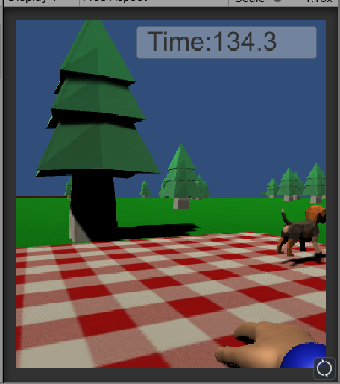

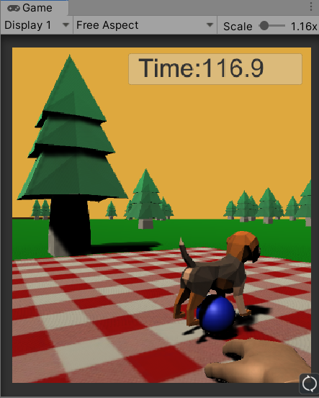

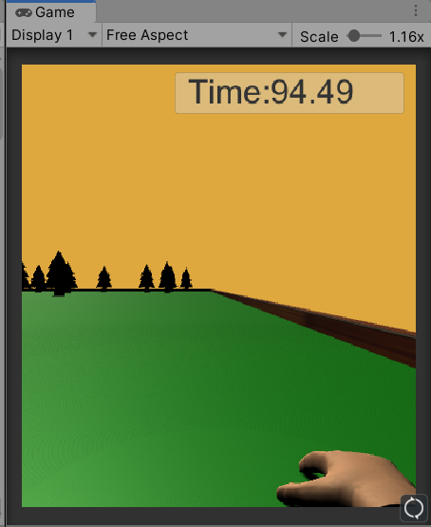

Evidently from the above images the textures and imported assets can be seen, they are low poly, appropriate, have the potential for animation and can be valuable parts of this project in the future.

Evidently I believe I have met the requirements of implementing visual cues into the virtual reality experience.

**5. User Interface** -User interface that can be interacted with and manipulatable to have a clear impact on the virtual world (the introduction of the timer value, which could be set to on or off dependent on a slider value accessible by the main menu impacted the mode of the game, additionally this changed whether the timer was present in the game as well as impacting the state of the rendered sky effectively increasing the visual cues, start interface, state machine pattern and autonomous movement).

**a. Satisfaction of particular requirement**

The user interface can be interacted with through the start and pause menu provided and described under section 7 of the required functionality. The UI element that I controlled was the timer element within the game. This could be changed by adjusting the value of a slider that was present in the main menu, which could be set at the start or returned to from the pause menu. The timer allowed the experience to be in an introductory state where the user could perform activities as many times as they want or a timed challenge where users had to complete a set series of actions before the time run out. Therefore, allowing the therapist to change the rate at which the user had to experience visual cues.

**b. Conducted research into solving the challenge**

The method of applying a timer seemed appropriate given the current context of the solution. The purpose for providing an introductory state first though was to detract from discomforting the user by applying the pressure of time. Therefore, the user could become familiar with the possible actions of the dog and then have to repeat this in a timed environment which could express with how much difficulty the user reads visual cues.

**c. Finding and reporting programming patterns or adapting and applying abstract concepts to produce professional quality results.**

Using the knowledge of adding UI interactions to an experience in unity, through the same references referred to in sub-heading 7 for required functionality. I attempted to implement the timer concept aided by a slider that dependent of value would be able to change this timer accordingly turning it on and off. First the slider was created and set to 0 and then if the slider was set to the value of 1 the timer state machine would become active. Unfortunately I was not able to complete this solution and resultingly I could change the value of the slider in the main menu and this would be registered and additionally the state machine would start if this value was set to 1 but unfortunately when transitioning from one scene to the next the slider value was reset and accordingly I settled with the timer being always on to still demonstrate the state machine of changing the color of the sky.

**d. Design solution**

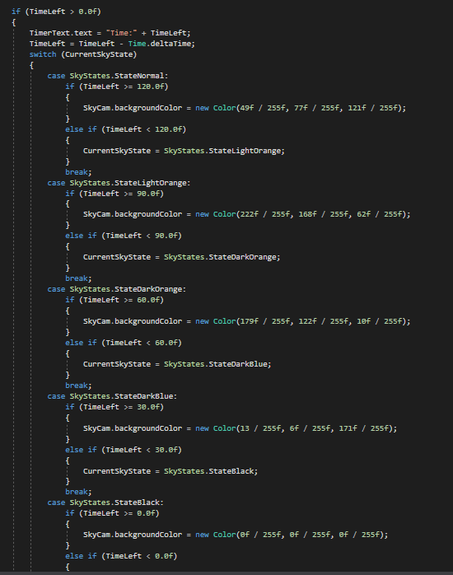

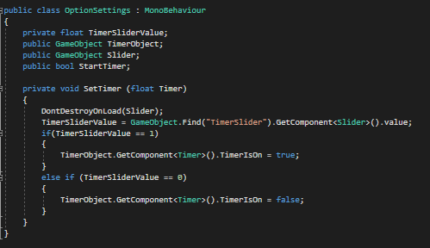

The two images above demonstrate that a boolean variable was planned to change whether the timer value referenced from another script that had reference to the timer object was set or not. Unfortunately, testing showed that the timer always worked as the timer value was always reset to 0 amongst starting the scene. Further investigations seems that this problem could potentially be solved using the player preferences function inbuilt into unity.

**e. Proof of functionality and testing**

-Testing mentioned as above.

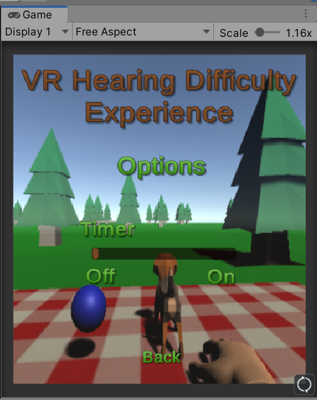

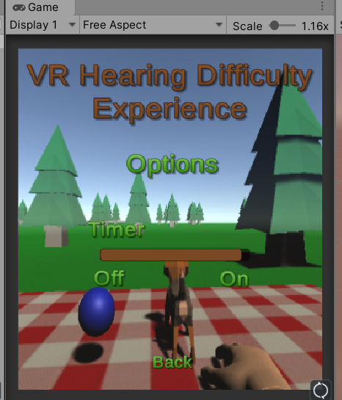

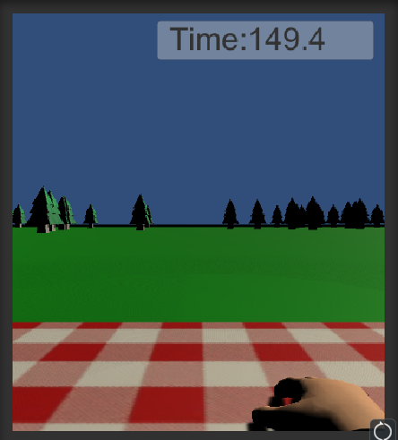

From the above three images, image one and two shows that the timer value could be successfully changed between two values using a UI slider in unity. This demonstrates my ability to use UI elements in addition to the buttons I used to navigate the UI menu. Unfortunately, I couldn’t fully complete the functionality of the timer and as a result it is always active in image3.

I implemented the UI element well and successfully except for the limitations provided by scene transitioning. I believe I completed most of the functionality for this requirement but not all.

**6. Autonomous Simulation** -Autonomous simulation, additional interaction with this autonomous simulation led to a high-quality solution (the autonomous simulation is present in two features. The smallest being the automatic state change of the rendered sky dependent on the timer value in the main menu, and the most important being the random positioning of the dog depending on current states, which included three sets of autonomous movements each impacted by the level of interaction with the user of the experience leading to a high quality solution).

**a. Satisfaction of particular requirement**

There are two sections of autonomous simulation that I created within my product solution. The first being the basic spawning of the scene and the second being the autonomous movement of the dog object that could be changed depending on the level of user interaction. The spawning scene spawns trees and fence prefabs, trees randomly within the boundary positioned by the ground as well as the removal for the possibility of trees to be spawned on the picnic rug area. Also, park fence prefabs are spawned to surround the boundary. This showcases my ability to implement autonomy whilst using arrays and loops. My second feature is the dogs autonomous movement which is sophisticated by the ability for user interaction to change this degree of autonomous movement. The dog is initially roaming around a section of the map, if the user interacts with the ball the dog will begin roaming around the picnic rug area, if the ball is thrown the dog will wait and then go to the ball, if the dog is patted it will go back to roaming the picnic rug and if it isn’t patted it will wait for a while and go back to roaming around the map making complete use of the state machine whilst implementing this feature.

**b. Conducted research into solving the challenge**

This task referenced my already known knowledge of creating autonomous movement and generating movement between two points based off my week3 problem solving challenge.

**c. Finding and reporting programming patterns or adapting and applying abstract concepts to produce professional quality results.**

For this challenge I reflected on the movement pattern I had previously created in the week 3 practical. I had learnt about random.range and used this feature to construct an area that trees could spawn inside then I would make sure the tree is not in the rugged area or it would be deleted. In theory this would mean that all the trees within the scene could be deleted but the chance of 200 trees being generated within a 50x50 space when they had potential to spawn in a 1000x1000 space is so small that it was neglected. Evidently multiple testing of this feature showed that out of a population of approximately 10 tests only 1 would have below 180 trees resulting in a statistically almost improbable event of no trees being spawned considering the smallest amount spawned was 179. Additionally, the dog movement has already been discussed in the state machine chapter and generates its movement from finding two different points within the boundary, if the points are the same generate a new point and if the points are not the same move towards the newly generated point. Providing constant autonomous movement, additionally this then included the dog moving within only the picnic rug area using the same principle, the dog standing still using the principle of position is same don’t move and then the dog moving towards the ball using a coroutine and then movetowards function.

**d. Design solution**

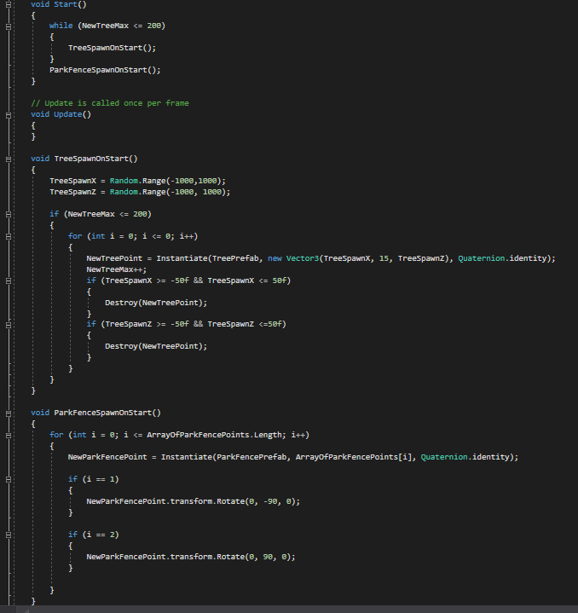

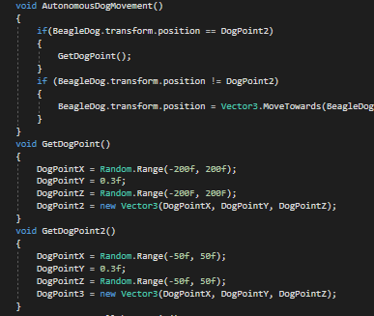

-Evidently image one shows the seemingly random autonomous spawning of the trees and the autonomous spawning of the fences.

-Image two shows the autonomous dog movement created between two points to create autonomous dog movement.

**e. Proof of functionality and testing**

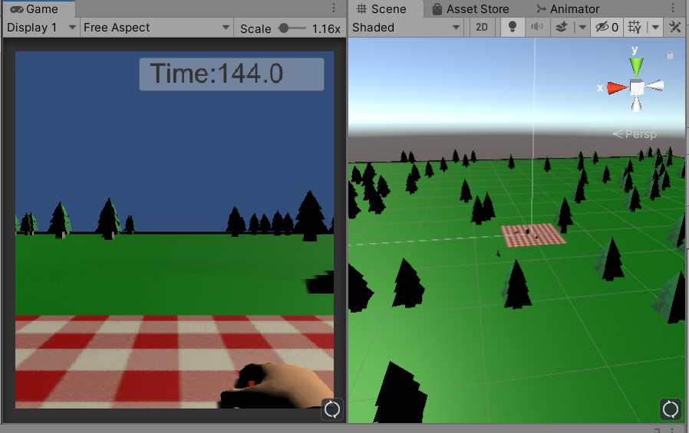

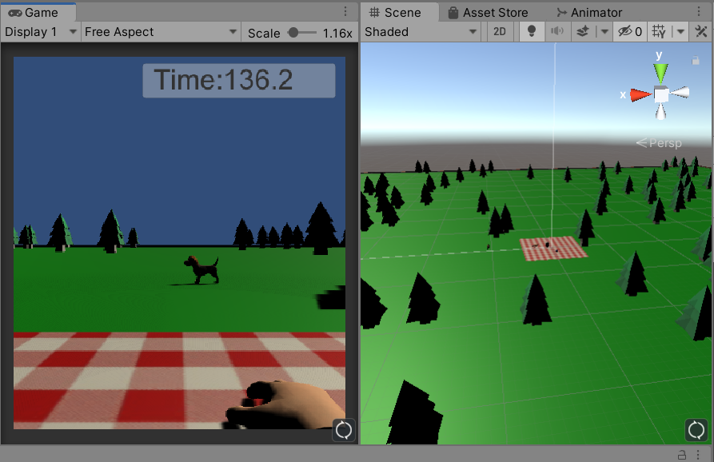

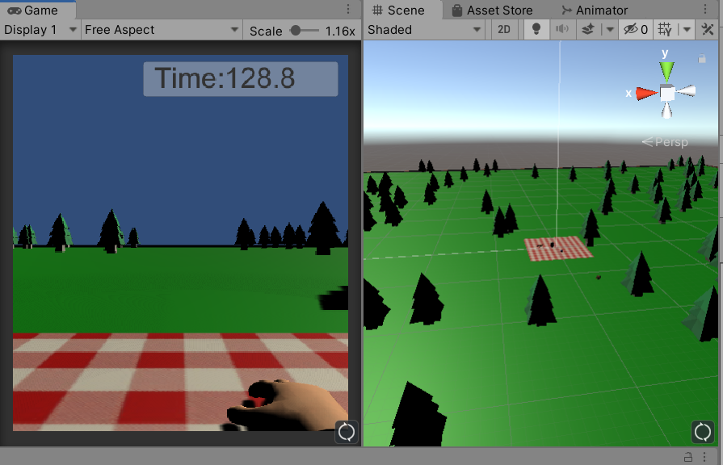

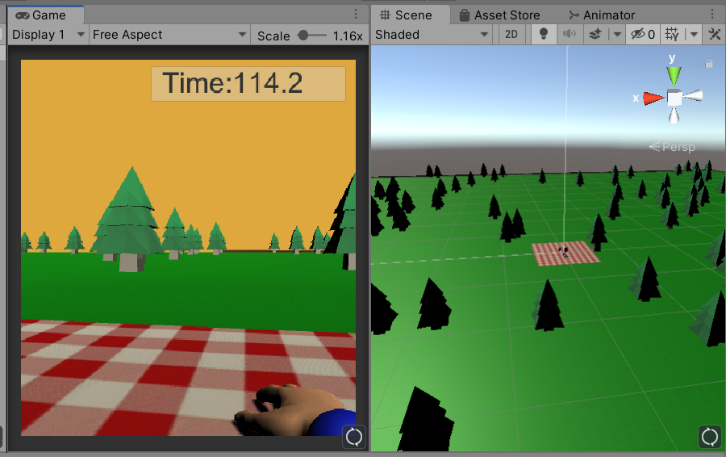

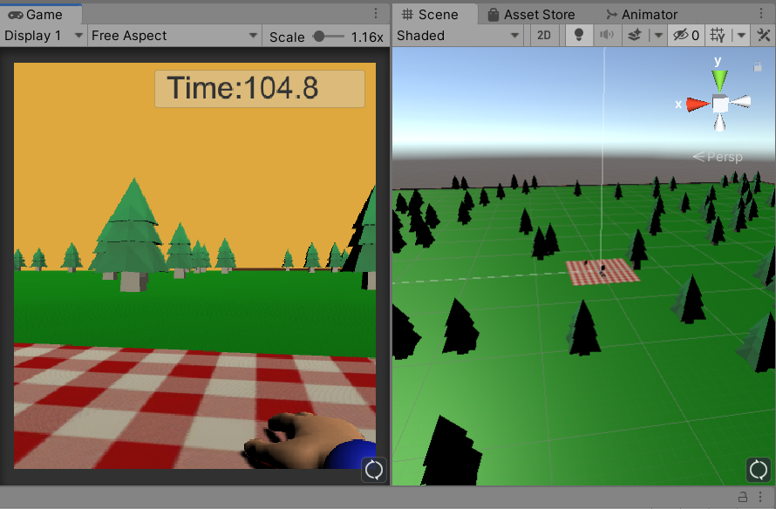

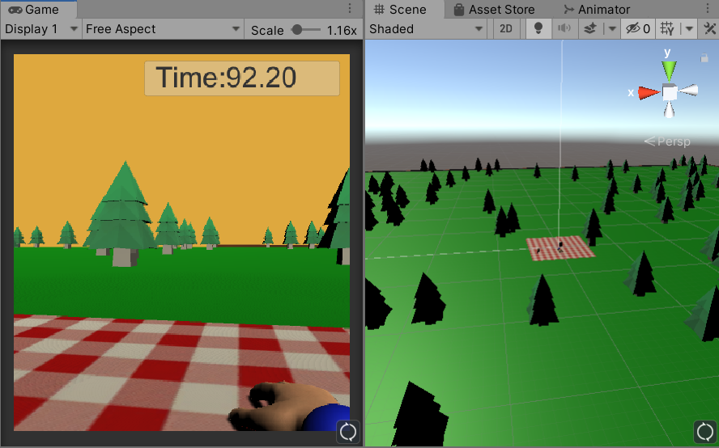

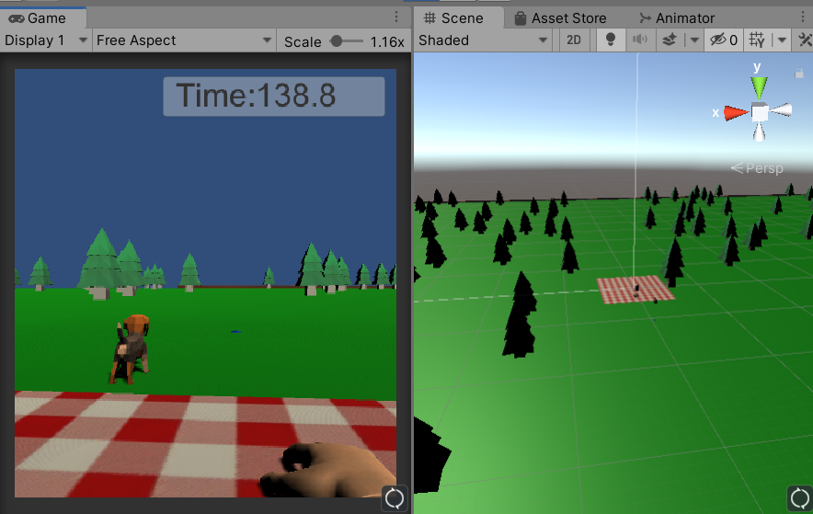

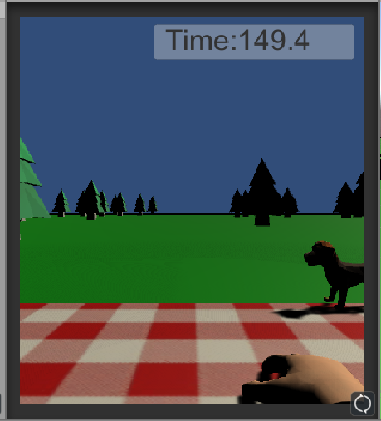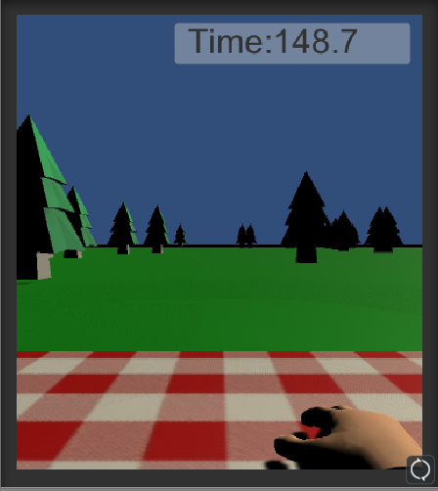

-Evidently image one, two and three demonstrate the autonomous movement of the dog around the specified section of the map when the ball object is not being collided with.

-Image four, five and six demonstrate the autonomous movement of the dog around a new specified portion when the ball had been collided with, appropriately adding a sophisticated level of autonomous movement that is dependent on user interaction. Image 7 demonstrates the dog making it’s path towards the ball regardless of the balls location.

-Observable in image eight and nine, two different instances of the autonomously spawned trees are shown. This allows the user to always be playing in a new experience also.

Required functionality for this solution is sophisticated, working and present.

**7. Application Start Screen** -The application includes a start screen with title, author details, purpose of experience, controls and the option to exit out of the experience. (I added a high level solution that included both the addition of a start screen and a pause screen within the experience, the start screen had a title and the following functionality based on buttons, options, details and controls sub-menu and the option to quit, the options menu had the ability to adjust the slider value and accordingly the timer value in the experience, the details menu explained the product and author details, and the controls menu explained the experience controls, quit functionality obviously quit the experience, the pause menu providing even further smooth flow in the experience, allowing the player to resume the experience, resuming the current time displayed on the timer if in use, reset the experience resetting both the experience and timer, the menu option allowing the user to return to the menu of the experience and another quit option to quit the experience from within the experience) Detailing a very high level quality of solution.

**a. Satisfaction of particular requirement**

The last challenge required an application start screen. As discussed above I added both a pause menu and a start menu increasing the functionality of the game and adding all the required functionality of the particular requirement. Both menu’s could be transitioned in and out of pausing the current time or resetting where necessary as well as providing somewhere for the UI slider to be positioned and accordingly the timer. The menu also leads from one scene to the another to start the scene or from the pause menu to go back to the start menu, and provides details and controls for the solution as well as an overall ability to quit the solution.

**b. Conducted research into solving the challenge**

To create this solution I needed to learn about the Unity UI features, in doing so I came across three videos by youtuber brackeyes for creating settings menus, start menus and pause menus ‘Reference9’, ‘Reference10’, ‘Reference11’ and in doing so was able to analyse the processes involved in creating Unity UI features.

**c. Finding and reporting programming patterns or adapting and applying abstract concepts to produce professional quality results.**

From here I created a series of text mesh gradients, text-boxes, buttons, button functionality and sliders to create a user interface and most importantly a pause and start menu to add depth to the experience.

**d. Design solution**

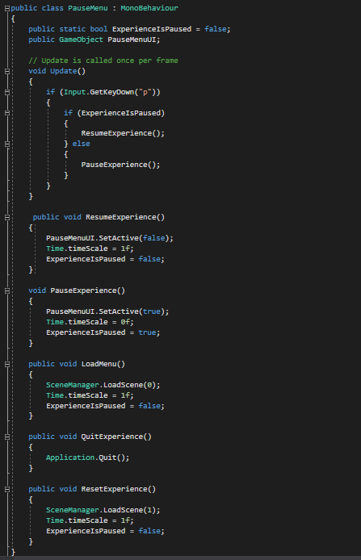

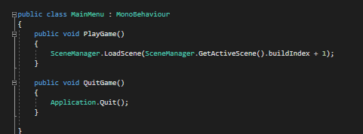

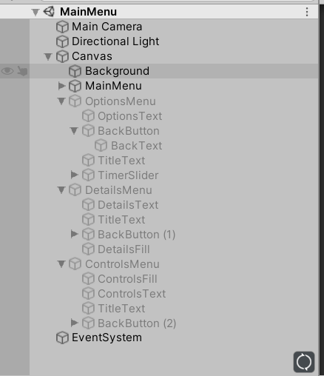

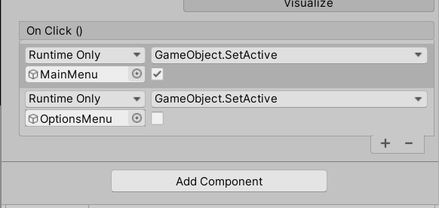

-As can be seen from above image one and two demonstrate the scripting functionality of accessing different scenes and applying the appropriate time pausing and resuming when necessary.

-Figure three and four show the development of the UI elements that make up the menu’s and how button functionality is added to these menus.

**e. Proof of functionality and testing**

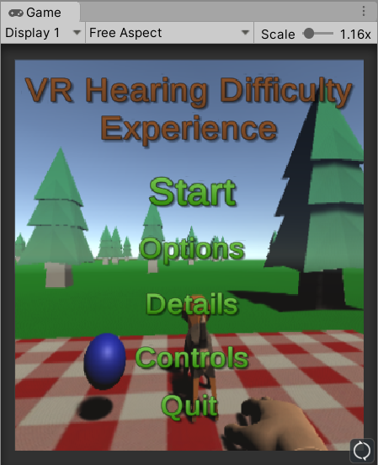

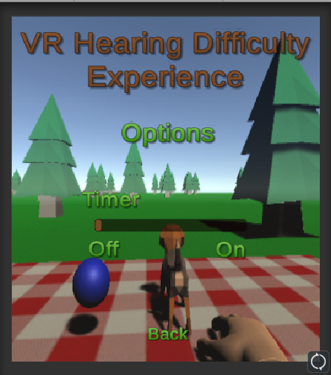

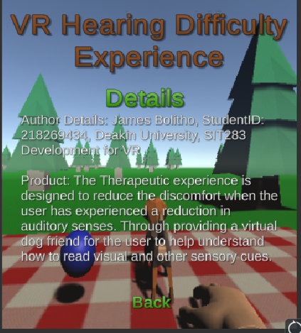

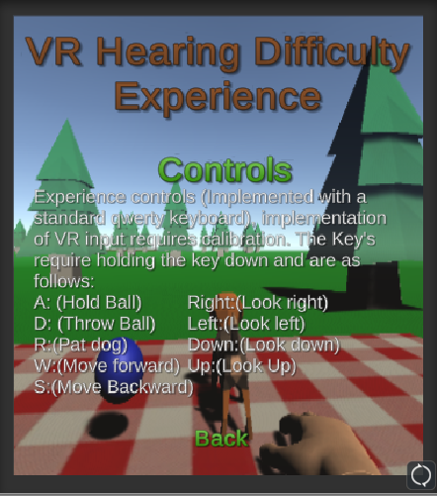

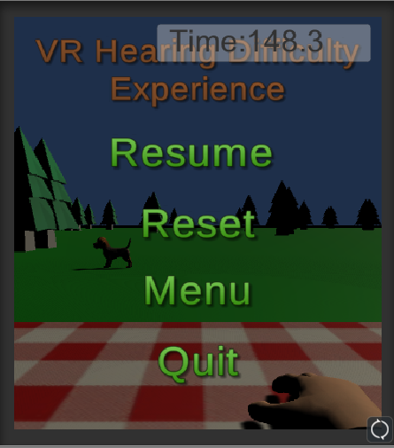

-The above five screenshots demonstrate the appearance of each menu and the sub-menu’s accessed by the buttons created on these menus.

I believe that I have satisfied all outcomes of this solution correctly.

**Operational instructions:**

Unity mode required to run: 2019.3.10f1

A keyboard to operate interaction within the game in the form of (w,s,a,d,p,left,right,up,down) keys.

Successful unzipping of the submitted zip file named VRDev.

Run Build named: VRDevelopmentChallenge located in build folder.

Process: When presented with the start menu you can explore each of the features freely, Start will transfer you to scene1 where the experience can be played. Options will show you the option to set the timer on or off, Details will explain the product and the author, Controls will represent all controls that can be used in the experience corresponding to the qwerty keyboard.

Upon playing the game the user can freely move around the map, the dog will be in an autonomous state. If the user collides with the ball (this is on the picnic rug) then the dog will begin autonomous movement within the picnic rug area. The ball is picked up holding ‘a’ it is best to move away from the ball and then pick the ball up in one swift motion to avoid the ball being dropped ‘ontriggerexit’ event may be called if you only collide and then pick it up. The user can move freely using the ‘w’ and ‘s’ keys to move forward and backward respectively and the ‘left’, ‘right’, ‘up’ and ‘down’ keys to change the direction being faced. Also when the user has picked up the ball and is holding down ‘a’ the user can release ‘a’ and press ‘d’ to throw the ball. (This will throw the ball depending on the current rotation of the player along the game axis). The player can also press ‘p’ at anytime to bring up the pause menu and reset the game or quit, or go back to the menu. When the user is touching the dog(done when the dog is at the position of the ball and still) they can press ‘r’ to pat the dog, which will be represented by the dog jumping up and down quickly once. If done it will go back to roaming the picnic rug area otherwise it will go back to roaming randomly.

There is also a video file attached with the submission showing the working solution on the authors computer (in case of difficulty submitting files/adding more evidence, etc..)

**References:**

**Reference1**

antiquote, 2015, ‘[Help] how do I reference/access another script in unity C#, viewed 19th May 2020, **<**<https://answers.unity.com/questions/1119537/help-how-do-i-referenceaccess-another-script-in-un.html>>.

**Reference2**

YoungDeveloper, 2013, ‘Can’t Understand GetComponent C#’, viewed 19th May 2020, <<https://answers.unity.com/questions/550578/cant-understand-getcomponent-c.html?_ga=2.184902369.936913070.1590370517-1678271274.1548639917>>.

**Reference3**

Mort, stackoverflow, 2012, ‘Unity3D: Change skybox color via script’, viewed 22nd May 2020, <<https://stackoverflow.com/questions/12551768/unity3d-change-skybox-color-via-script>>.

**Reference4**

Martynov, Unity-assetstore, handforVR, viewed 24th May 2020, <[**https://assetstore.unity.com/publishers/10649**](https://assetstore.unity.com/publishers/10649)**>.**

**Reference5**

Nitacawo, Unity-assetstore, DogBeagle, viewed 24th May 2020, <[**https://assetstore.unity.com/publishers/22323**](https://assetstore.unity.com/publishers/22323)**>.**

**Reference6**

Synchronic, Unity-assetstore, LowPolyTree, viewed 24th May 2020,

<[**https://assetstore.unity.com/publishers/19854**](https://assetstore.unity.com/publishers/19854)**>.**

**Reference7**

Vincent, HighResolution TEXTURES, ‘7Transparent Background WoodFence Textures’, viewed 25th May 2020, <<http://www.highresolutiontextures.com/free-wood-fence-3d-textures-pack-with-transparent-backgrounds>>.

**Reference8**

kjpargeter, freepik.com, ‘Abstract background with red and white squares’, viewed 24th May 2020, <<https://www.google.com/search?q=red+and+white+squares+texture+free&tbm=isch&ved=2ahUKEwiar_-o_M3pAhUoH7cAHS6hBMQQ2-cCegQIABAA&oq=red+and+white+squares+texture+free&gs_lcp=CgNpbWcQA1DFDVj3EWC2EmgAcAB4AYAB7AGIAe4FkgEFMC4yLjKYAQCgAQGqAQtnd3Mtd2l6LWltZw&sclient=img&ei=5i3LXpqkFKi-3LUPrsKSoAw&bih=603&biw=1229&rlz=1C1CHBF_en-GBAU785AU785#imgrc=UStf0smVJSrjRM>>.

**Reference9**

Brackeys, youtube.com, ‘START MENU In Unity’, viewed 26th May 2020, <<https://www.youtube.com/watch?v=zc8ac_qUXQY>>.

**Reference10**

Brackeys, youtube.com,’PAUSE MENU in Unity’, viewed 26th May 2020,<<https://www.google.com/search?q=pause+menu+in+unity+brackeyes&rlz=1C1CHBF_en-GBAU785AU785&oq=pause+menu+in+unity+brackeyes&aqs=chrome..69i57j33l3.4134j0j8&sourceid=chrome&ie=UTF-8#kpvalbx=_fpfMXvLpCJbA3LUPpcSt-Ac30>>.

**Reference11**

Brackeys, youtube.com, ‘SETTINGS MENU in Unity’, viewed 27th May 2020, <<https://www.youtube.com/watch?v=YOaYQrN1oYQ>>.